TRYHACKME · TUTEDUDE CYBERSECURITY TRACK · TASK 10
Cross-Site Scripting
Stored XSS — Unsanitized Input Executed in the Victim's Browser

Platform: TryHackMe Room: tutedude-cybersec Category: Cross-Site Scripting
Prepared by: Farhan Date: August 16, 2026
FLAG CAPTURED
FLAG{STORED_XSS_ACHIEVED}
Objective
This task targets the SecureCorp Employee Portal, a TryHackMe lab application, with the goal of identifying and exploiting a Cross-Site Scripting (XSS) flaw. Credentials for a standard, low-privileged account were obtained in a prior task via review of the client-side source code; this task picks up from that authenticated foothold and focuses on injecting and executing attacker-controlled JavaScript in the context of another user's browser session.
Environment & Tools
Target | SecureCorp Employee Portal (TryHackMe lab instance)
Platform | TryHackMe — tutedude-cybersec room
Tools Used | Browser DevTools / view-source, Chromium-based browser
Vulnerability Class | Stored Cross-Site Scripting (XSS)
Scope (as stated)
“Perform an XSS (Cross-Site Scripting) attack on the website and pop up an alert to get the flag.”
Methodology
Step 1 — Identifying Candidate Injection Points
After authenticating with the disclosed low-privileged credentials, the portal exposed two user-controlled input fields that reflected data back to a page: the Employee Directory search box ("Search the internal global directory by employee name") and the Support Board's "Report an issue" message field, which posts to a Community Thread visible to all employees and the CEO. Both were treated as candidate injection points for a stored or reflected XSS payload.
Step 2 — Attempt #1: Employee Directory Search
The following payload was submitted into the Employee Directory search field:
<script>alert('XSS attack, you are hacked')</script>
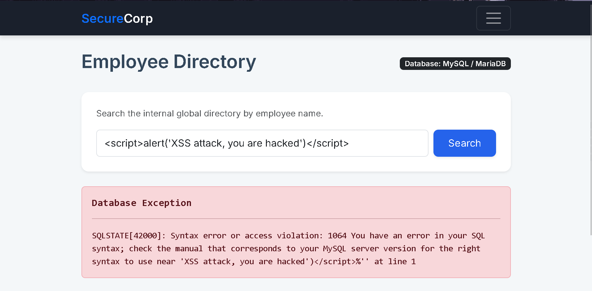
Figure 1 — Employee Directory search field with the XSS payload submitted.
The request failed. Instead of an alert popup, the application returned a raw database exception: SQLSTATE[42000]: Syntax error or access violation, referencing the single-quote (') character inside the payload as the point of failure. This indicates the search field passes user input directly into a MySQL/MariaDB query without parameterization or escaping — a SQL injection weakness on its own — but the unescaped quote also breaks the query before the response is ever rendered as HTML, so the script tag never reaches the browser intact. This injection point was therefore parked as a separate (SQL injection) issue rather than a working XSS vector, and testing moved to the second candidate field.
Step 3 — Attempt #2: Support Board Message
The Support Board's Community Thread displays every submitted message to all employees, including the CEO, making it an attractive target for a stored XSS payload — a message a low-privileged user posts here would later execute in the browser of any employee who views the thread. The board's normal state, prior to submission, is shown below:
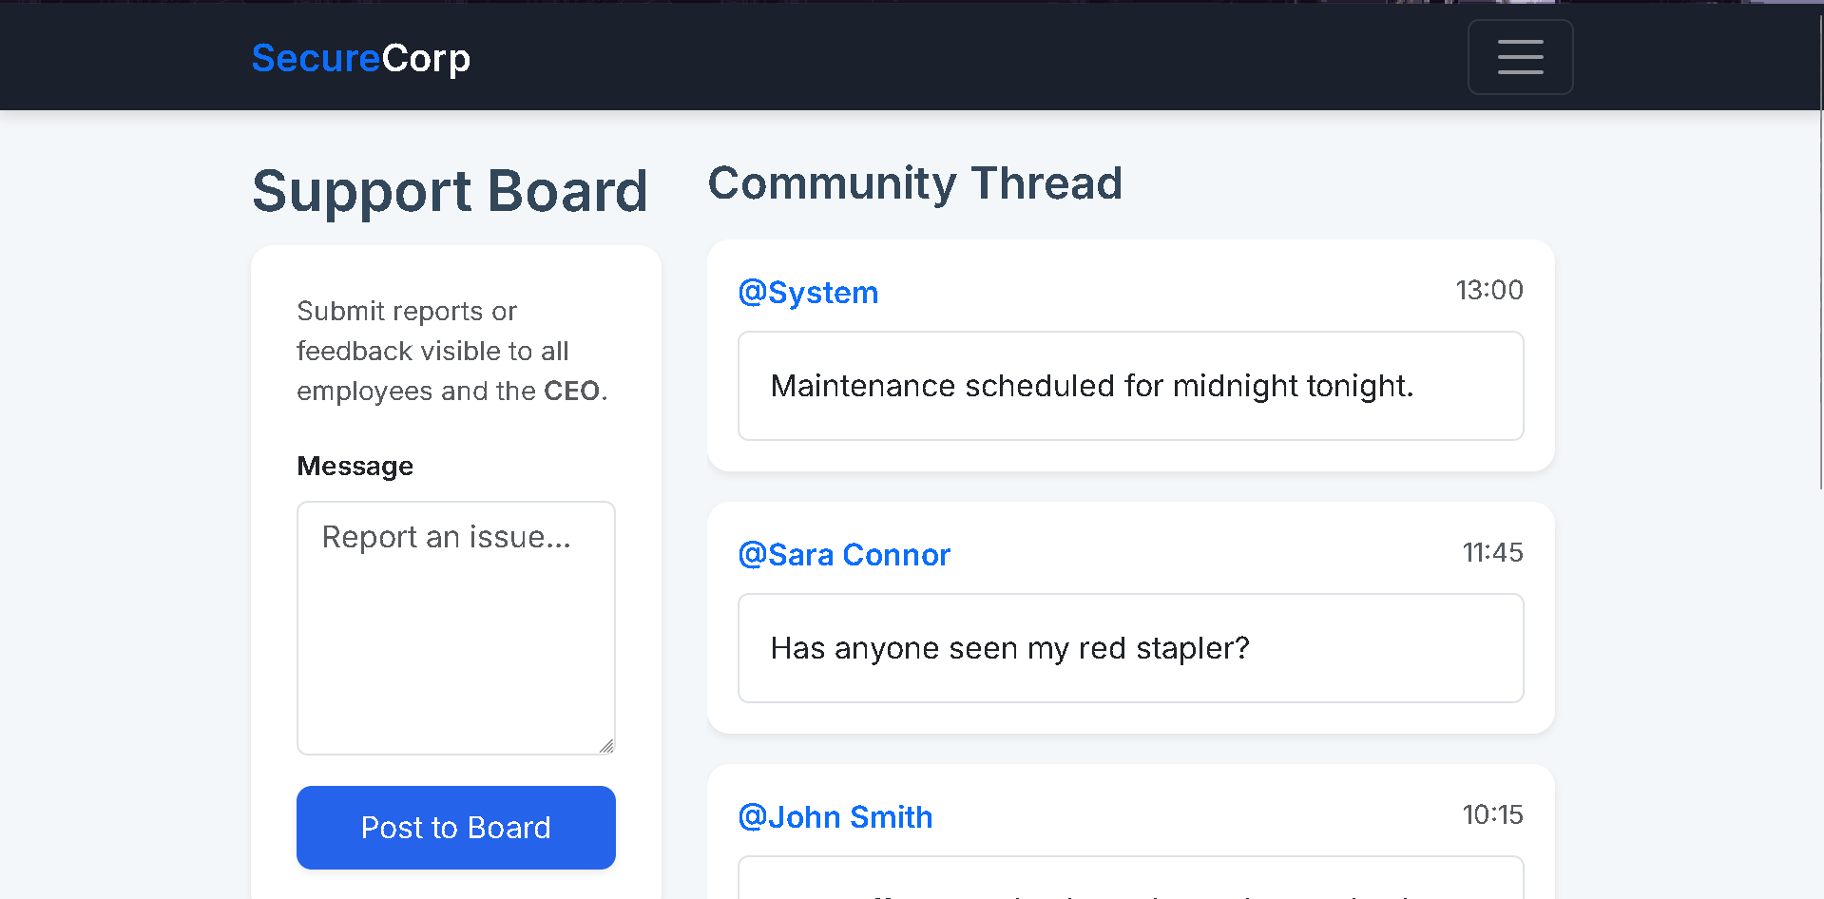
Figure 2 — Support Board's Community Thread prior to payload submission.
The identical payload used in Step 2 was entered into the "Report an issue" message box and submitted via Post to Board:
<script>alert('XSS attack, you are hacked')</script>
Step 4 — Confirming Execution and Capturing the Flag
The Support Board field performs no output encoding or sanitization on the message it stores and later renders. When the Community Thread reloaded, the stored payload was written directly into the page's HTML and the browser's parser executed it as live JavaScript, firing the alert() popup. Immediately below the injected post, the application flagged the entry as "UNSANITIZED INPUT DETECTED" and displayed the objective flag alongside an "INJECTION SUCCESS" marker:
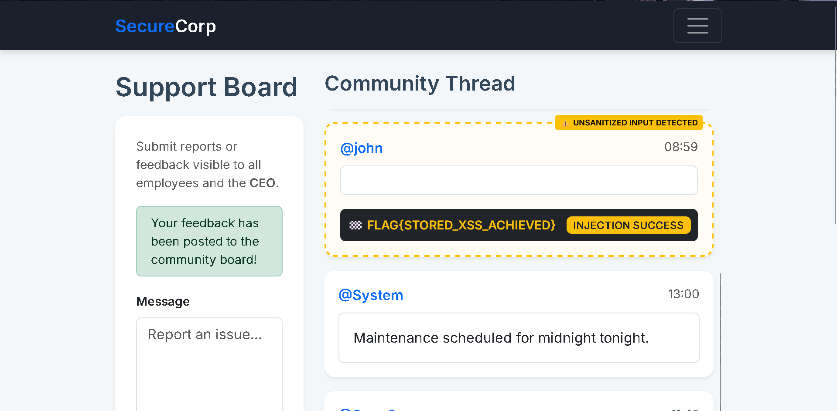
Figure 3 — Stored payload executes in the Community Thread; the application surfaces the flag and confirms injection success.
This confirms the vulnerability is a classic stored XSS: the Support Board persists attacker-supplied HTML/JavaScript and later serves it, unescaped, to every visitor of the thread, so the script executes in the victim's browser exactly as if it were part of the site's own trusted code.
Step 5 — Flag Submission
The captured flag was submitted to the lab platform's answer field and validated as correct, closing out the objective.
Figure 4 — Flag accepted as the correct answer on TryHackMe.
Vulnerability Analysis
Vulnerability | Stored Cross-Site Scripting — unsanitized user input executed in other users' browsers
OWASP Category | A03:2021 — Injection
Weakness (CWE) | CWE-79: Improper Neutralization of Input During Web Page Generation ('Cross-Site Scripting')
Severity | High — arbitrary JavaScript execution in the browser of any user who views the Community Thread, including the CEO
The Support Board takes free-text user input from the "Report an issue" field and, when rendering the Community Thread, inserts it directly into the page's HTML without HTML-encoding special characters (<, >, ", ') or applying any allow-list / sanitization step. Because the browser cannot distinguish between the site's own markup and attacker-supplied markup once both are concatenated into the same HTML response, a submitted <script> tag is parsed and executed with the same trust and privileges as the application's legitimate JavaScript — including access to the victim's cookies, session, and DOM. The Employee Directory field exhibits a related but distinct failure: it interpolates user input directly into a SQL query, which is why a single unescaped quote broke the query outright rather than allowing script execution.
Impact
- Arbitrary JavaScript supplied by any authenticated (even low-privileged) user executes in the browser of every other user who views the Community Thread, including administrators and the CEO.
- A stored payload persists on the server, so a single successful post compromises every future visitor of the page until the message is removed — no repeated interaction from the attacker is required.
- In a real deployment this primitive could be used to steal session cookies, perform actions on behalf of the victim, deface the page, or pivot into further attacks such as credential harvesting via injected fake login forms.
- The related Employee Directory field demonstrates that user input reaches a backend SQL query unescaped, suggesting a second, independent injection class (SQL injection) alongside the XSS finding.
Remediation Recommendations
- HTML-encode all user-supplied content at the point of output (encode <, >, &, ", ') rather than attempting to filter or blacklist specific tags such as <script>.
- Adopt a templating engine or framework that auto-escapes output by default, and only mark content as "safe/raw" through an explicit, reviewed exception.
- Apply a strict Content-Security-Policy (CSP) header to prevent inline scripts from executing even if a payload slips through output encoding.
- Validate and sanitize input on the server side for both the Support Board and Employee Directory fields; for the directory search, use parameterized queries / prepared statements instead of string concatenation into SQL.
- Set the HttpOnly attribute on session cookies so that even a successful script injection cannot exfiltrate the session token via document.cookie.
Conclusion
This task demonstrates a textbook Stored Cross-Site Scripting vulnerability (OWASP A03:2021): the Support Board accepts free-text input and later renders it into the page without neutralizing HTML/JavaScript special characters, allowing a submitted <script> tag to execute in the browser of anyone who views the thread. An initial attempt against the Employee Directory search field was blocked by an unrelated SQL syntax error rather than any real defense, pointing to a second, likely SQL-injection-class weakness in that field. Exploitation of the Support Board was fully reproduced end-to-end and confirmed via the FLAG{STORED_XSS_ACHIEVED} flag.
FLAG{STORED_XSS_ACHIEVED}

